**Power BI Projects**

Welcome to my Power BI Projects repository! Here, you'll find a collection of eight different Power BI dashboards that I've created, each focusing on a unique aspect of data visualization and analysis. These projects were developed using real-time data extracted from surveys and other datasets.

**End Project**

For the End Project, I utilized a unique dataset to showcase a comprehensive analysis and visualization, which includes a wide range of data from a survey. This project represents the culmination of my Power BI skills, bringing together various techniques and insights. Below, you'll find the dataset used and a sample screenshot of the dashboard.

**Dataset Name: Data Professional Survey**

**Sample Picture of End Project Dataset:**

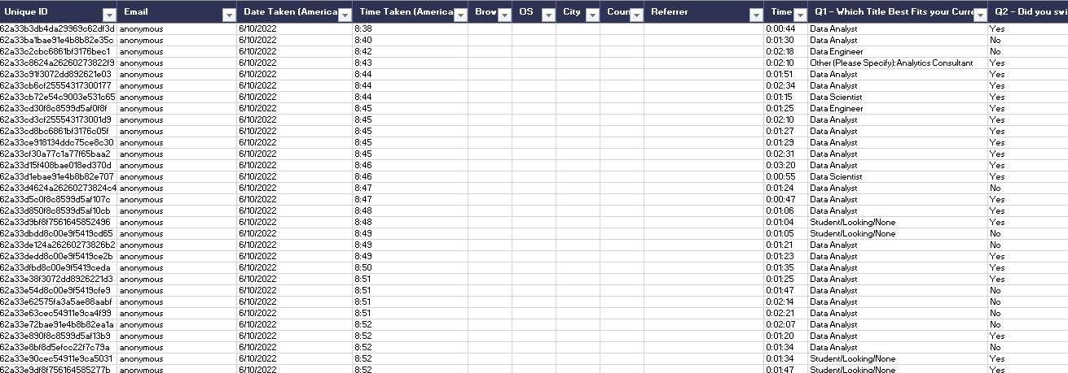

**Dashboard:**

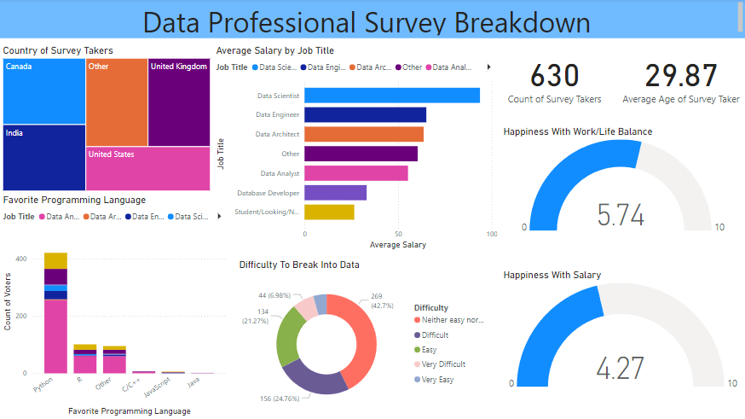

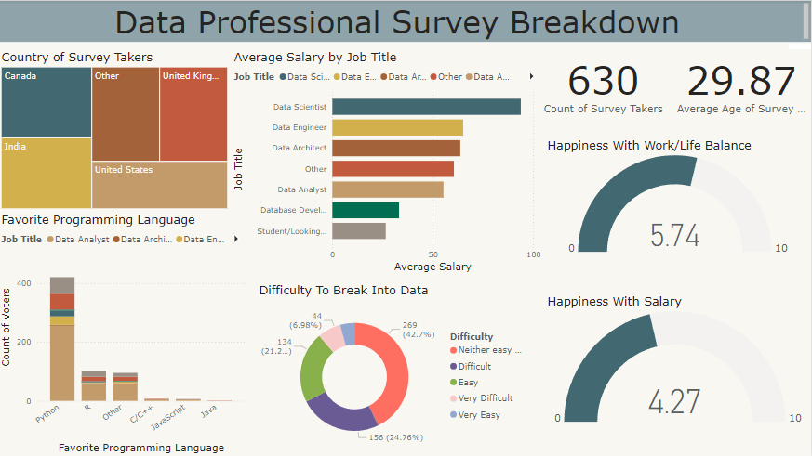

**Other Projects**

The following projects were created using the 'Apocalypse Food Prep' dataset, which includes a wide range of data from a store. This dataset captures various details such as store, date, time purchased, date purchased, products, quantity, average and sum of products sold and more.

**1. Beginner Power BI**

**Dataset Name: Apocalypse Food Prep**

**Dashboard:**

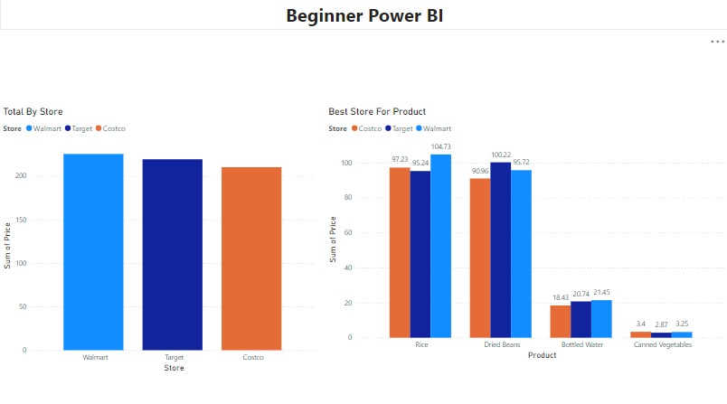

**2. Bins and Lists**

**Dataset Name: Apocalypse Food Prep**

**Dashboard:**

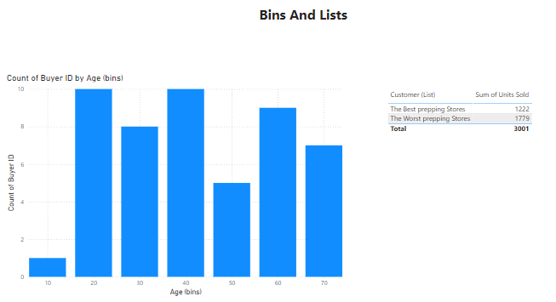

**3. Conditional Formatting**

**Dataset Name: Apocalypse Food Prep**

**Dashboard:**

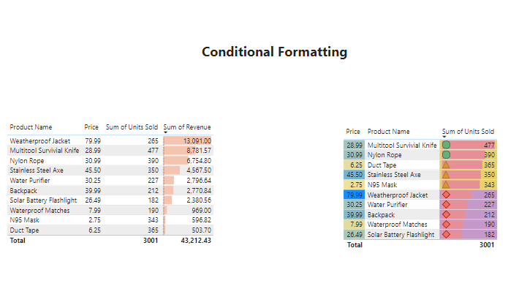

**4. DAX in Power BI**

**Dataset Name: Apocalypse Food Prep**

**Dashboard:**

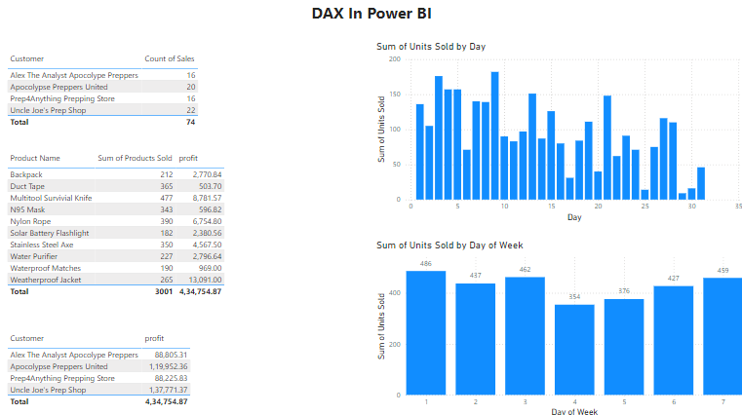

**5. Drill Power BI**

**Dataset Name: Apocalypse Food Prep**

**Dashboard:**

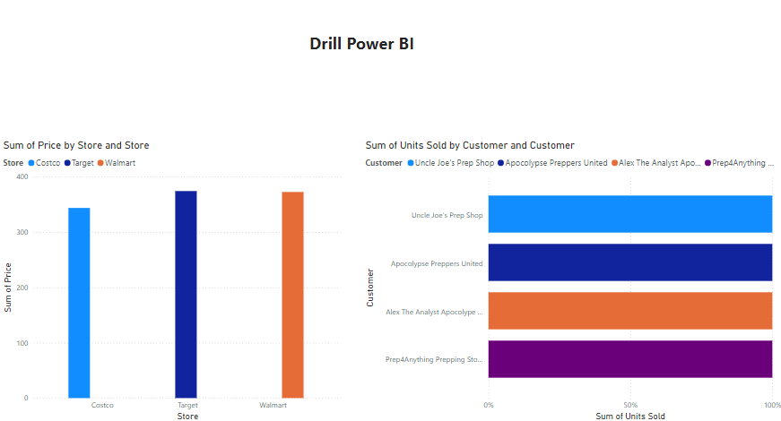

**6. Power BI Queries**

**Dataset Name: Apocalypse Food Prep**

**Dashboard:**

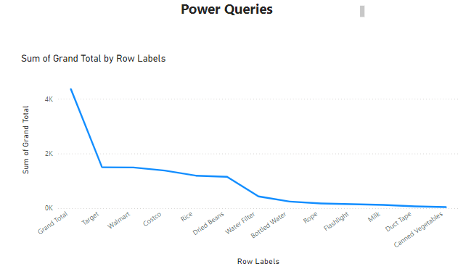

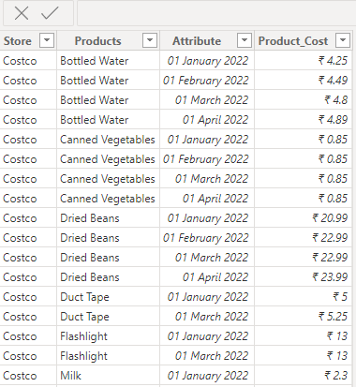

**7. Virtualizations**

**Dataset Name: Apocalypse Food Prep**

**Dashboard:**

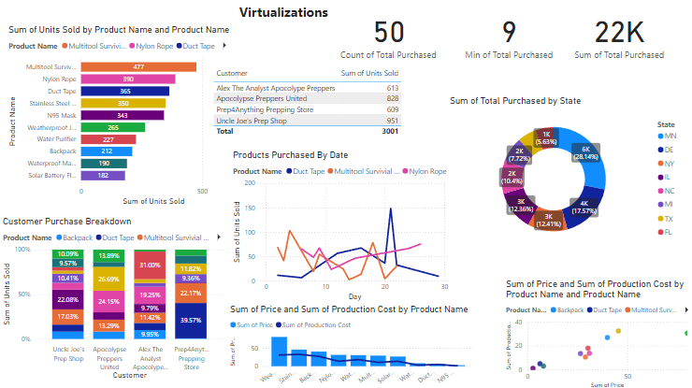

**Sample Photos of Apocalypse Food Prep Datasets:**

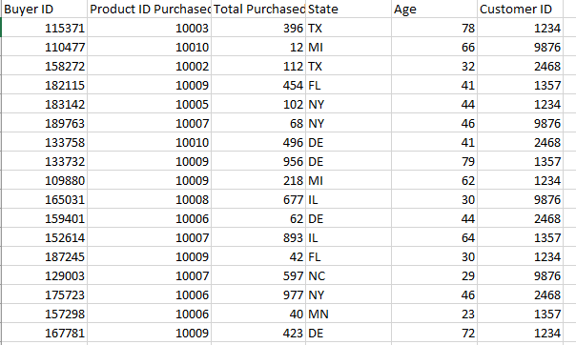

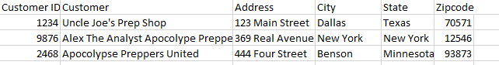

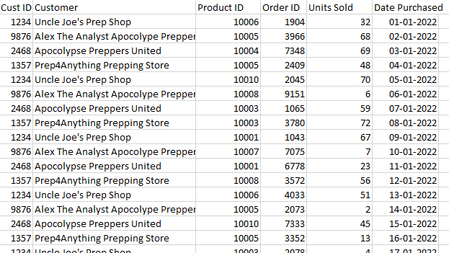

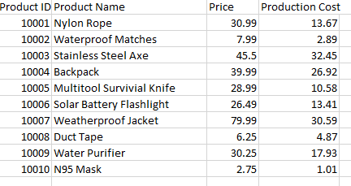

**About the ' Data Professional Survey ' Dataset**

The 'Data Professional Survey ' dataset is a rich source of information gathered from a detailed survey. It includes the following data points:

* Unique ID
* Email
* Date Taken (America/New York)
* Time Taken (America/New York)
* Time Spent
* Current Role
* Career Switch into Data
* Current Yearly Salary (in USD)
* Industry
* Favourite Programming Language
* Job Satisfaction (Salary, Work/Life Balance, Coworkers, Management, Upward Mobility, Learning New Things)
* Difficulty Breaking into Data
* Most Important Job Search Factor
* Gender
* Age
* Country of Residence
* Highest Level of Education
* Ethnicity
* Average Salary

**About the 'Apocalypse Food Prep' Dataset**

The 'Apocalypse Food Prep' dataset is a comprehensive collection of survey data. It includes a variety of details about each respondent and their purchasing habits. Here are the key data points included in this dataset:

* Buyer ID
* Product ID
* Purchased
* Total Purchased
* State
* Age
* Customer ID
* Product Name
* Price
* Production Cost
* Revenue
* Customer
* Order ID
* Units Sold
* Date Purchased
* Address
* City
* State
* Zip code

This rich dataset allows for detailed analysis and visualization, providing insights into customer demographics, purchasing patterns, product performance, and more.

Feel free to explore each Power BI file and dataset to see how I've utilized this data to create insightful and visually appealing dashboards.